Regulations:
A15

H.T No

Sreenidhi Institute of Science and Technology
(An Autonomous Institution)
Code No: 5B202 Date: 07-June-2018 (AN)

B.Tech I-Year II-Semester External Examination, May/June - 2018 (Supplementary)
Engineering Drawing – II (Common to All)

Time: 3 Hours Max.Marks:75

Note: a) No additional answer sheets will be provided.
b) All sub-parts of a question must be answered at one place only, otherwise it will not be valued.
c) Missing data can be assumed suitably.

Part - A Max.Marks:25

Answer all QUESTIONS.

1. | What is a Diagonal scale? What are its applications? | [3M]
2. | Explain about “Radial Line Method” of development of surfaces. | [3M]
3. | Draw the isometric view of a circle of diameter 60mm on any principal plane. | [3M]
4. | Explain about “Offset Method” in drawing isometric views. | [3M]
5. | What is a perspective projection? List three important characteristic features of perspective projections. | [3M]
6. | Describe how to create the image of a line about any axis in AUTOCAD? | [2M]
7. | Mention the applications of scale of chords. | [2M]
8. | Give the applications of “Development of Surfaces”. | [2M]
9. | Distinguish between isometric view and isometric projection. | [2M]
10. | Name the two methods of drawing perspective views in engineering practice. | [2M]
Part – B Max.Marks:50
ANSWER ANY FIVE QUESTIONS. EACH QUESTION CARRIES 10 MARKS.

11. |  | An area of 6250 square kilometres is shown as a rectangle of 125 cm x 200 cm. Draw a backward Vernier scale to show decametre and long enough to measure up to 7 km. Mark a distance of 6.43 km on the scale. | [10M]
12. |  | A cone of base diameter 60 mm and axis 70 mm is resting on its base on HP. A section plane perpendicular to VP and inclined at 45⁰ to HP bisects the axis of the cone. Draw the development of its lateral surface. | [10M]
13. |  | A hexagonal prism of base side 30mm and axis 70 mm is resting on its base on the HP with a side of the base parallel to VP. It is cut by a section plane perpendicular to VP and inclined at 45⁰ to HP and bisecting the axis. Draw the isometric view of the object. | [10M]
14. |  | Draw the orthographic projections of the isometric view shown in the figure.  X  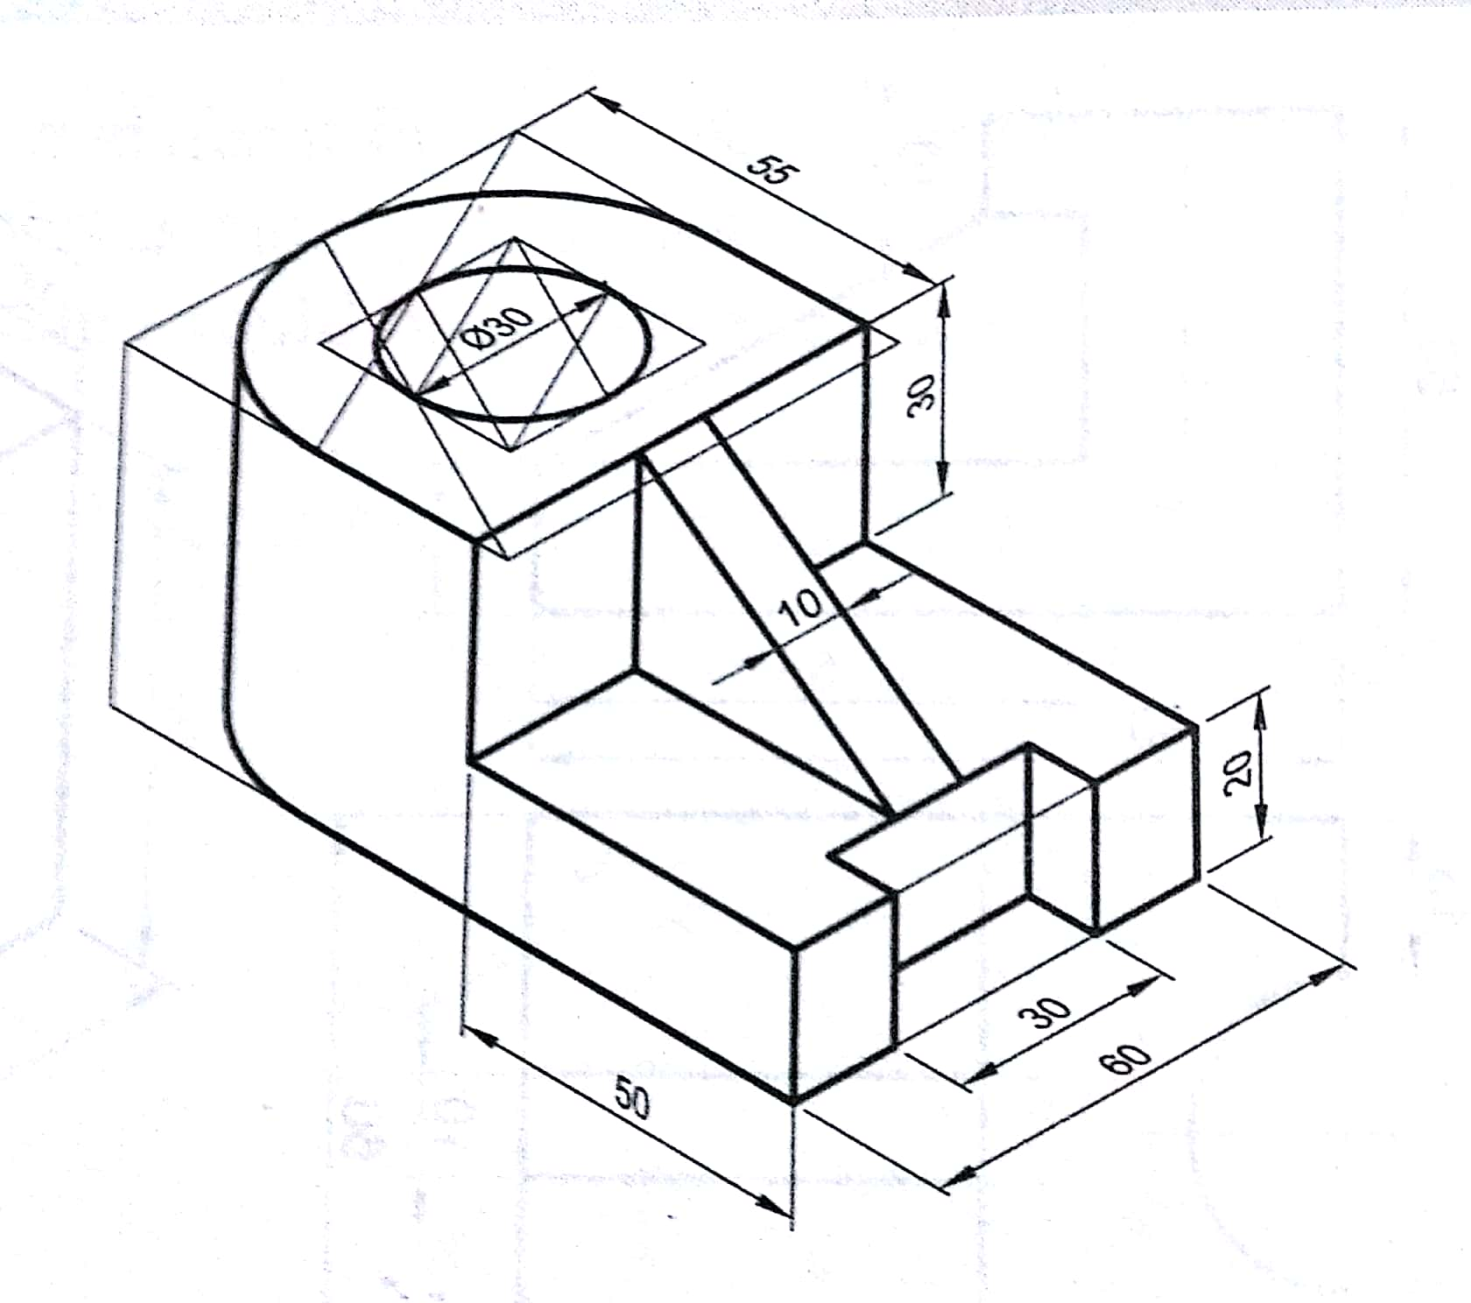 | [10M]
15. |  | A hexagonal plane of side 30 mm lies on the GP with an edge parallel to and 10 mm behind the PP. The station point is 60 mm in front of PP, 75 mm above GP and lies in a CP which is 40 mm towards the right of the centre of the object. Draw the perspective view of the plane. | [10M]
16. |  | Explain the AUTOCAD commands used in the creation of (i) Circle (ii) Hexagon (iii) Spline Curve (iv) Cone and (v) Pyramid. Choose arbitrary dimensions. | [10M]
17. |  | Draw the isometric projection of the frustum of a hexagonal pyramid of base side 40 mm and top side 25 mm and height 70mm. The frustum rests on the base on the HP. | [10M]
18. |  | Draw the orthographic projections of the isometric view shown in the figure.  X  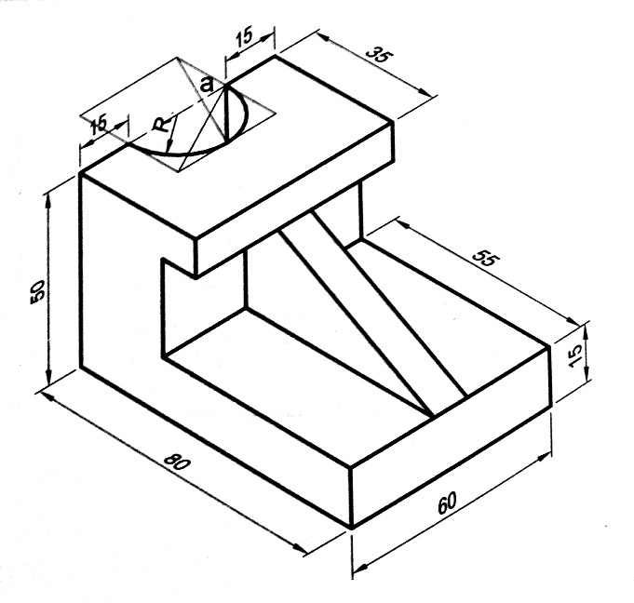 | [10M]
-- 00 -- 00 –

